CU Text Autotext Element
This cool tool allows you to add an autotext element to a page layout which shows CU information for design features within the current map extent. The autotext element displays for each work location, the feature assigned to it, the feature's work function (e.g., install, remove), and the number of features. To use this autotext element, you must have features assigned to work locations. Any feature not assigned to a work location will not be accounted for in the display.
- Register the CU_ATE.dll using the Regx.exe utility provided with ArcFM. The DLL should be registered in codebase. By default this tool is installed here: C:\Program Files (x86)\Miner and Miner\ArcFM Solution\Bin.
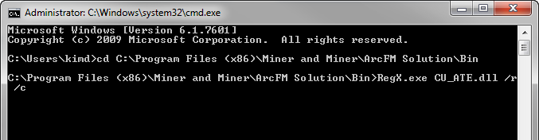
- Add the "ConstructionNotesXslPath" configuration value through the Process Framework Administration tool. This value will point to the location of the style sheet that should be used for the autotext element. A sample style sheet is provided with the solution.
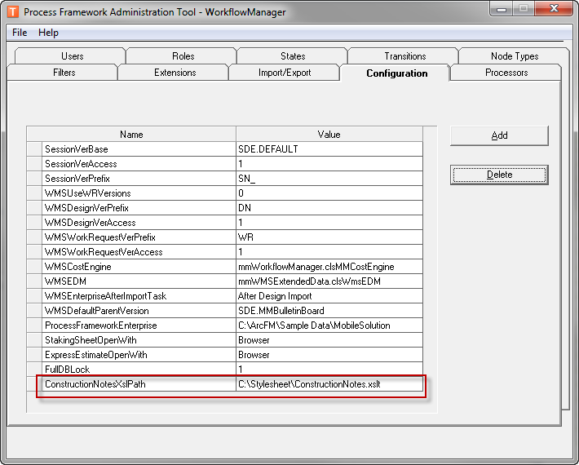
- Open a design and add the new autotext element to a page layout.
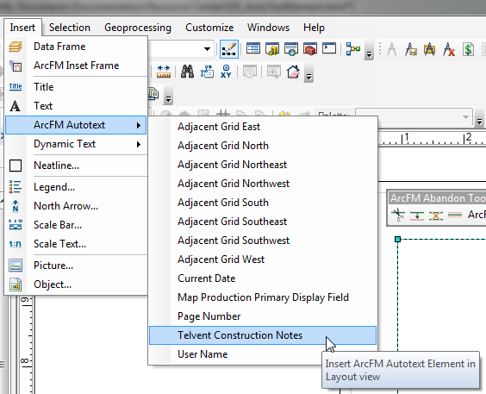
- To view construction notes, the design must have work locations to which features are assigned, and you must save the design. View Print Preview to see the new autotext element results for the current design.
